

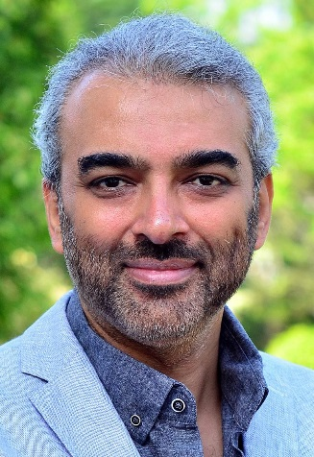

Universiti Teknologi PETRONAS, Department of Electrical & Electronic Engineering

Assoc. Prof. Dr Aamir Saeed Malik

05 - 368 7853

1995, Master in Nuclear Engineering by Quaid-i-Azam University Pakistan  
Information & Mechatronics (Image Processing  
Information & Communication (Image Processing) by Gwangju Institute of Science & Technology  
Electrical Engineering by University of Engineering & Technology

Keyword:

* Computer Science
* Engineering
* Medicine
* Mathematics
* Social Sciences
* Physics and Astronomy
* Energy
* Materials
* Science
* Biochemistry,
* Multidisciplinary Decision Sciences
* Immunology and Microbiology
* Genetics and Molecular
* Biology
* Business, Management and Accounting
* Chemical Engineering
* Neuroscience
* Environmental Science
* Health Professions
* Psychology
* Earth and Planetary Sciences
* Chemistry
* Agricultural and Biological Sciences

Publications: